基于微信小程序的在线书城

摘要

小程序是一种不需要下载安装即可使用的应用，它实现了应用「触手可及」的梦想，用户扫一扫或者搜一下即可打开应用。借助小程序，应用将无处不在，随时可用，但又无需安装卸载。另一方面，面对阅读收费化，广告化的趋势，我们希望给用户提供免费、舒适、纯粹的阅读体验，让微读成为用户的移动图书馆，用深度的内容去对抗浮躁的世界。基于以上两方面，我Based on the analysis of Ebola outbreaks in current situation, we infer that the best Ebola Eradication strategy can relieve World’s Ebola disease and control the spread of Ebola. In this paper, we develop five models to achieve these goals from five aspects: the spread of the disease, delivery system, locations of delivery, the drug demands and the speed of manufacture. We also use our models to discuss the isolation and incoming passenger volume impacts of our strategy.

**关键字:** 微信小程序, H5阅读器, 网络爬虫, Loopback, mongodb

目录

摘要 1

1 前言 3

1.1 项目介绍 3

1.2 项目背景 3

2 The Model of Ebola spreading in the world 3

2.1 Restatement and Analysis 3

2.2 Variable declaration 3

2.3 The Spread of Ebola Model 4

2.3.1 The cases of Ebola 4

2.3.2 The Spread Areas of Ebola 10

3 Drug Diversion Model 12

3.1 Background 12

3.2 Modeling 12

3.2.1 Ebola outbreak Areas 12

3.2.2 Assumptions and Justifications 13

3.2.3 Drug Supply and Drug Demand Areas 13

3.2.4 Minimum Spanning Tree Method (MST) 13

4 Drug and Vaccine Production 17

4.1 Background 17

4.2 Assumptions and Justifications 17

4.2 Variable declaration 18

4.3 Modeling 18

4.3.1 Population Prediction Model 18

4.3.2 Drug demand Prediction 20

4.3.3 Drug Production Model 21

5 The optimized isolation Area in SIRES Model 22

5.1 new Assumptions and Justifications 22

5.2 new Variable Declaration 22

5.3 The Isolation Index Analysis 22

6 Paper for the world medical association 24

References 25

Appendix 25

# 1 前言

## 1.1 项目介绍

小程序是一种不需要下载安装即可使用的应用，它实现了应用「触手可及」的梦想，用户扫一扫或者搜一下即可打开应用。借助小程序，应用将无处不在，随时可用，但又无需安装卸载。另一方面，面对阅读收费化，广告化的趋势，我们希望给用户提供免费、舒适、纯粹的阅读体验，让微读成为用户的移动图书馆，用深度的内容去对抗浮躁的世界。结合以上两方面，我们使用微信小程序作为前端基础，使用nodejs以及数据库mongodb作为后台支撑，搭建了一个移动端阅读应用--微书。

## 1.2 项目背景

E

# 2 The Model of Ebola spreading in the world

## 2.1 Restatement and Analysis

Many diseases spread through human populations by contact between infective individuals (those carrying the disease) and susceptible individuals (those who do not have the disease yet, but can catch it). The pattern of these disease causing contacts forms a network. In this paper we investigate the effect of network topology on the rate and pattern of disease spread. The Ebola

## 2.2 Variable declaration

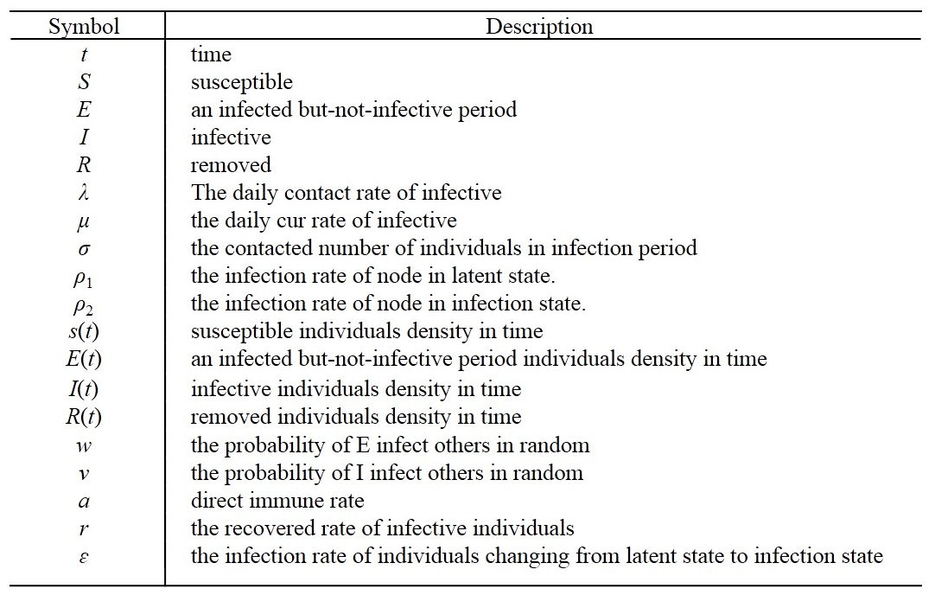

## 2.3 The Spread of Ebola Model

The spread of Ebola not only has the characteristic that the number of patient will change with time, but also has the characteristic that the severely afflicted areas of Ebola will extend from the center to neighboring areas. Thus, for the spread model of Ebola virus, we consider two aspects-the quantity and the spread.

### 2.3.1 The cases of Ebola

Firstly, we assume the model is:

* To treat the research objects as ideal crowds and to keep the total number of crowds at a fixed level N.
* There is no death resulting from migration and other reasons.
* The people who once had been infected have longtime immunity, and that the incubation period of the virus is too short to consider, which means that a patient can soon become an infector.

We use the complex network model WS to simulate the real world. In this model, everyone is regarded as a node in the network and the connection between individuals is edge in the network. In reality, there is no clear boundary between acquaintances (connection with edge) and strangers (connection without edge).Strangers will become acquaintances through some contacts, thus topological structure in network is changeable. Based on this, model SEIRS, which featuring random remote infection mechanism (the node of infection status and latent state infects its neighboring nodes by a certain rate while it randomly infects strange nodes without edge by a certain rate), was came up with in the first part of this chapter.

The transforming relationship between each state in the following picture.

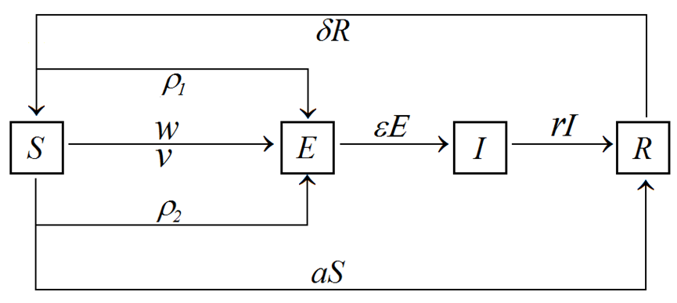

Fig 1. The Map of SEIRS Model

We can get the following equation according the previous diagram of model.

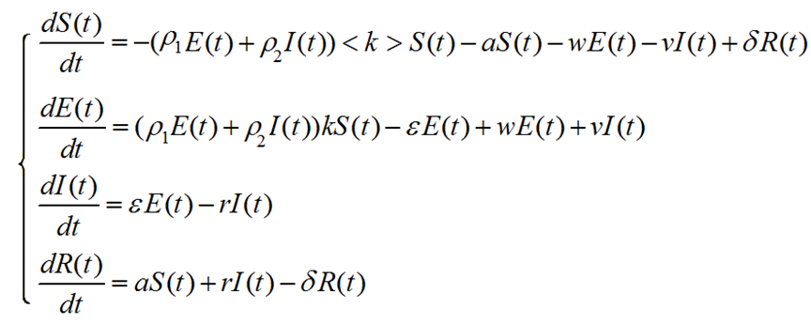

Let *ρ*=(*ρ*1*E*(*t*)+*ρ*2*I*(*t*)), according to the condition of normalization，

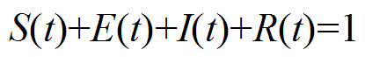

The equation set can be transformed to



We account the cases and the deaths in the outbreak countries every five days. Then we obtain the data as Tab 1.

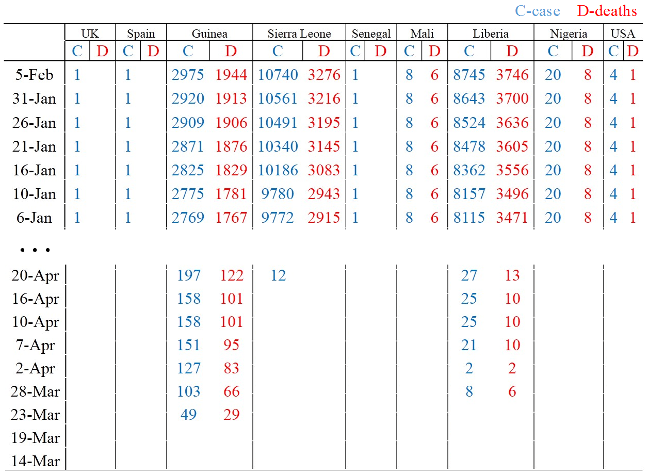

Tab 1. The outbreak cases in the world[2] (From March 14th 2014 to Feb 5th 2015)

Otherwise, we find the groups of E individuals as Tab 2.

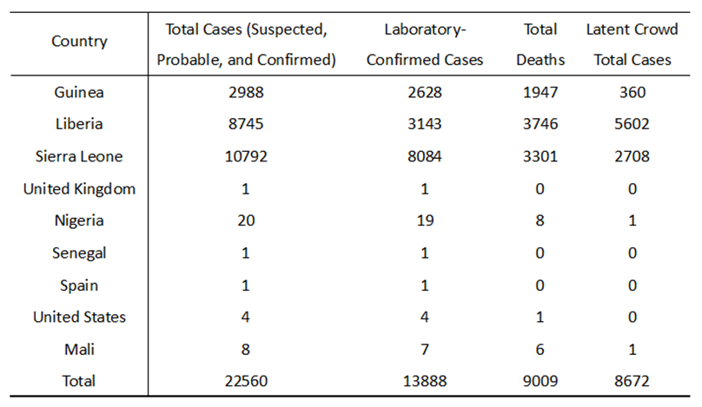

Tab 2. The Latent Crowd total cases

We have tried lots of different parameters based on the previous statistics as Tab 3.

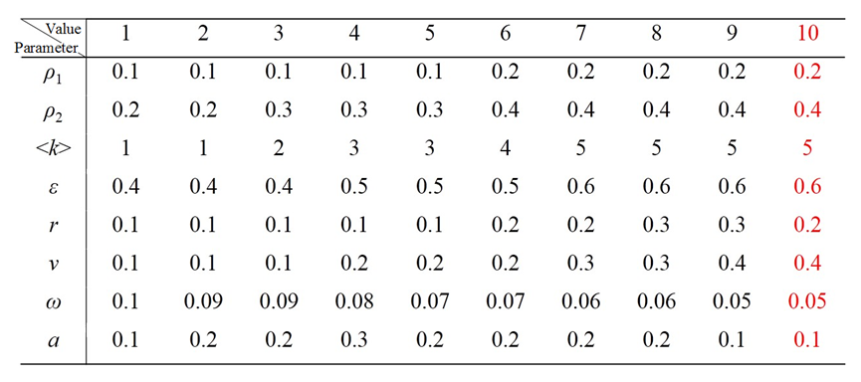

Tab 3.the different combination of parameter in the ODE

Take Guinea for example, We put the different combination of parameter in the ODE, then utilize the MATLAB solve the ODE, and draw the I(t)-t line as follow Fig2

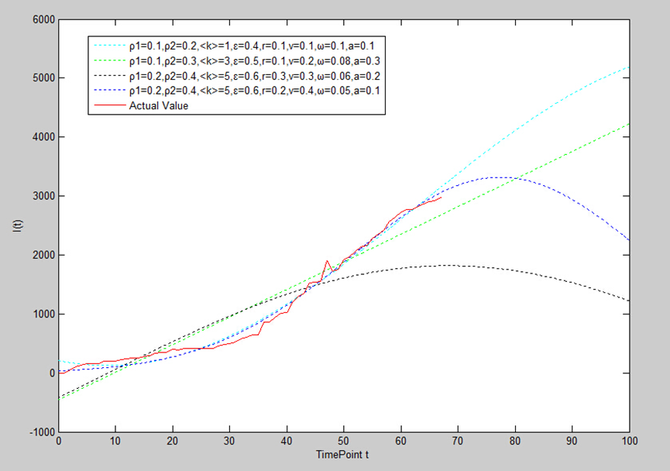

Fig 2. the I(t)-t line result from ODE

From this figure, we conclude that the blue line fits the actual value. In other words, when *ρ*1=0.2, *ρ*2=0.4, <*k*>=5, *ε*=0.6, *r*=0.2, *v*=0.4, *ω*=0.05, *a*=1, the theoretical curve fit the actual line best. We also do the same work with S(t), E(t) and R(t), and get the same group of parameter.

After that, we put the group of the parameter into our model. And we get the numerical solution of S，I，R relating to t by solving the previous differential equations through MATLAB. At the same time, we compare our model with real statistics we found, and the picture is the result.

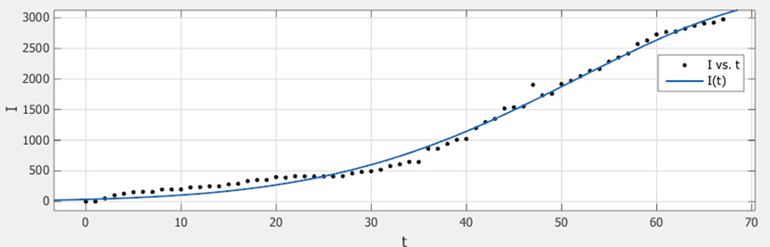

Fig 3. The comparison of I between real statistics point and the theoretical curve

From Fig 3, we assume that the I(t) is go up with the time going by. At first, I(t) increase slow due to the base number is small. Then, the base number of infective individuals increase, other individuals have more risk to be infected by the infective individuals, so the number of infective individuals rise quicker.

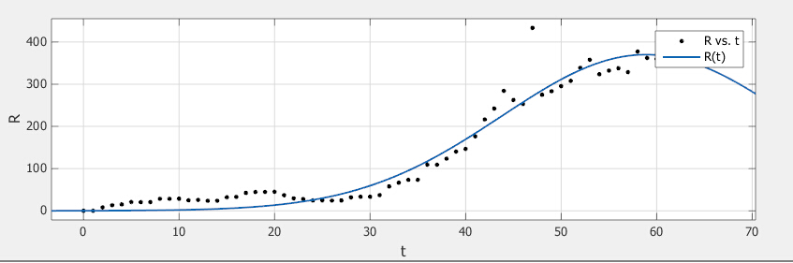

Fig 4. The comparison of R between real statistics point and the theoretical curve

From Fig 3, we assume that the R(t) is fluctuate as the time goes by. At first, R(t) increase slow due to the base number is small. Then, the base number of infective individuals increase, more infective individuals have been removed from the infective individuals, so the number of removed individuals rise quicker. With the medical treatment, there are less infective individuals,

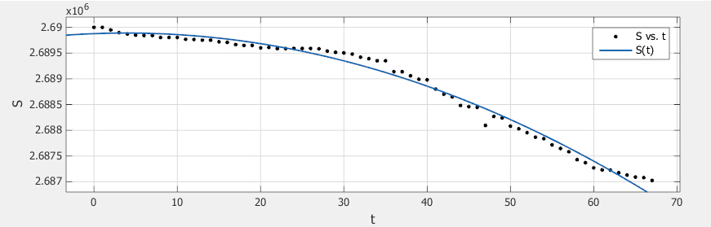

Fig 5. The comparison of S between real statistics point and the theoretical curve

The previous result shows that our model, which can rather accurately reflect the real development state of Ebola，has achieved a better result. The given statistics can only verify the early development stage of Ebola, because Ebola has not developed to a equilibrium. In the following stage, by numerical calculation, we will determine the balanced point in the development of the virus and predict its future development.

Referring to the definition of equilibrium in differential equation，when Ebola develops to equilibrium, every set of equations set comes to zero, and then we can get the transformation relationship between S(t),E(t),I(t)and R(t).

There is threshold value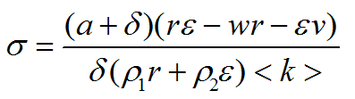in our complex network system.

a) When δ is greater than or equal to 1, system will have an equilibrium point of non-illness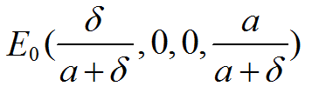, and the point is inclined to a stable state all the way.

b) Whenδ<1, there is the only equilibrium point of endemic illness and the point is inclined to a stable state all the way.



When put the parameter which we have got, we can get

C:\Users\pony\Documents\Tencent Files\364498319\FileRecv\无标题24.png

Thus there is a equilibrium point of Ebola’s endemic development

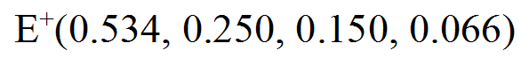

Before reach the equilibrium point, the trend is ascent, after that, the trend is descent.

Based on the analysis, we can predict the development trend of Ebola in the future as Fig 6.

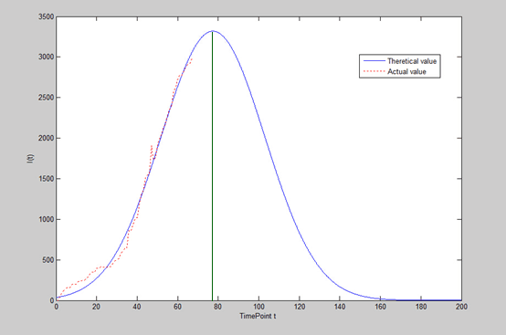

Fig 6. comparison of Infective individuals between Actual and Theoretical value

From the figure, we read when t=77, the infective individuals get the maximum, the date is about April 4th 2015. After that, the cases will decrease. When t = 180, the disease will be controlled.

### 2.3.2 The Spread Areas of Ebola

We acquired the data every fine day form March 14th 2014 to Feb 5th 2015, the set of the data is composed of daily number of cases and deaths in the outbreak countries, which can be used to account the buffer zone of the number of cases and the boundary in the outbreaks in the following months. The weight function of buffer zone is related to population density, medical grade, passenger volume and cases in the outbreaks. See the picture as follow.

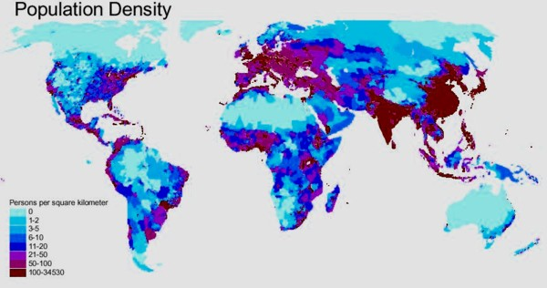

Fig 7. the population density of the world[2]

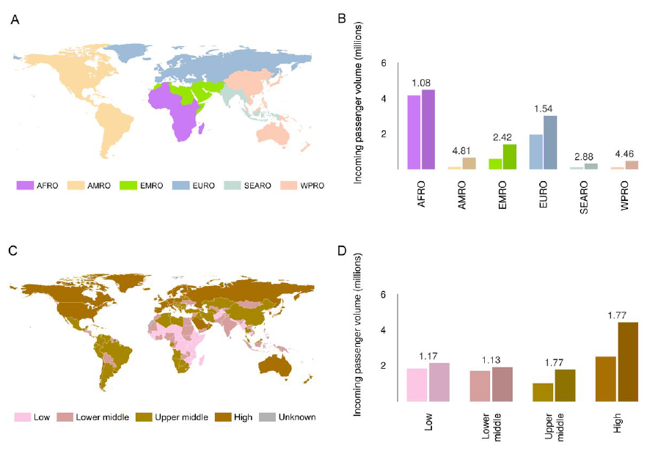

Fig 8. incoming passenger volume of the world[4]

This model use the MATLAB to analyze the number of cases in the following 2 months .Then based on the population density, medical grade, passenger volume and cases in the outbreak countries, we get the buffer zone by analyzing the weight function through software ArcGIS.

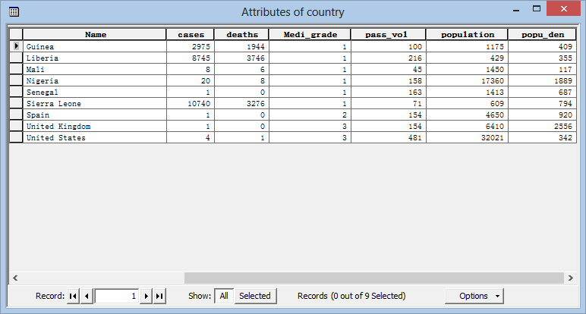

Fig 9.

After calculation with the weight function, it turns out to be a layout as the following picture.

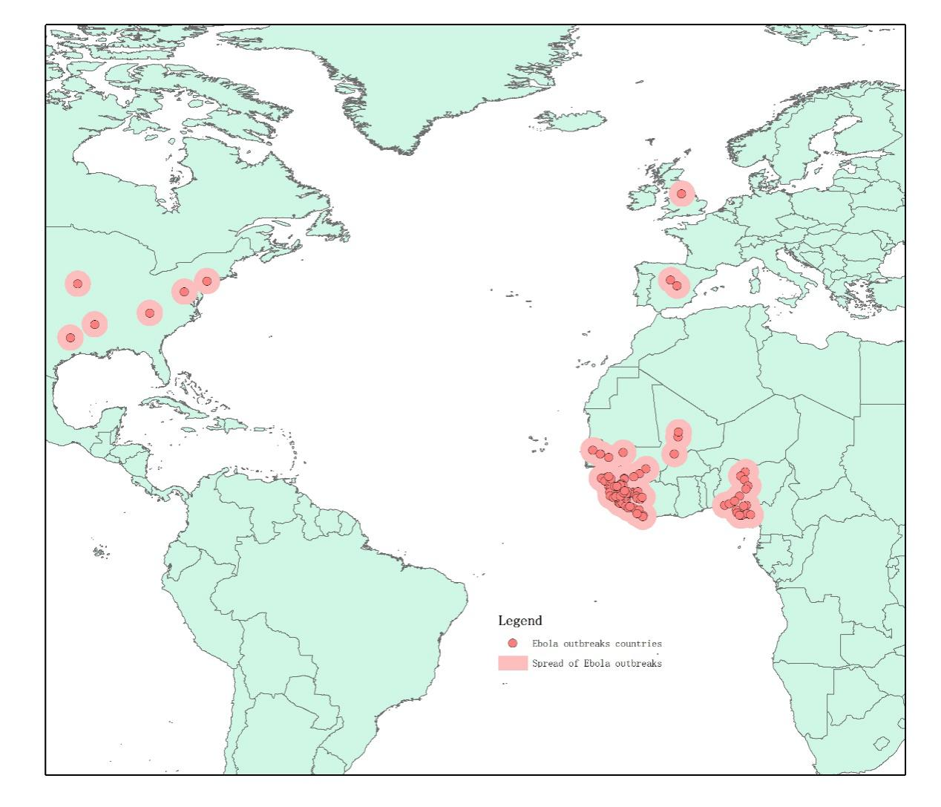

Fig 10.

# 3 Drug Diversion Model

## 3.1 Background

The Ebola is very close to be constrain by some measurement. For the most significant, it is high time for inhabitants to have Drugs. We need to convey the drugs to from the pharmaceutical factory to the Ebola outbreak countries. At first, we need to know where the pharmaceutical factory is and which country need the medicine. The new medicine, made by Max Planck Biopharmaceutical Companies located in San Diego, California in the United States, is ZMapp (http://zh.wikipedia.org/wiki/ZMapp). We can build a possible feasible delivery systems and decide the location of delivery system based on the manufacturing location of new medicine and the outbreak areas of Ebola.

## 3.2 Modeling

### 3.2.1 Ebola outbreak Areas

Currently, Ebola outbreaks in the following countries: Sierra Leone, Liberia, Guinea, Nigeria, Mali, United States, Senegal, United Kingdom and Spain. These area need most wanted rescue form the world medical association. This model use a network to make the delivery process work effectively.

### 3.2.2 Assumptions and Justifications

* Each of outbreak area need medicine supply.
* No matter by land or by air, adjacent areas are passable to each other.
* The route linking every two infection areas is the shortest one.
* Transportation facilities will not make virus spread.

### 3.2.3 Drug Supply and Drug Demand Areas

We select drug supply and demand areas depending on the areas’ amount of cases in the Ebola outbreaks countries.

Considering receiving the drugs more convenient, we choose the areas which have plenty of cases. The infected patients in these places are rather intensive, thus we can make a concentration delivery of the medicine to the related outbreaks.

So, we can find some areas’ relative data in Tab 1. More remarkable, all the areas are labeled in Tab 1.

Tab 1. the Ebola outbreaks in the all countries

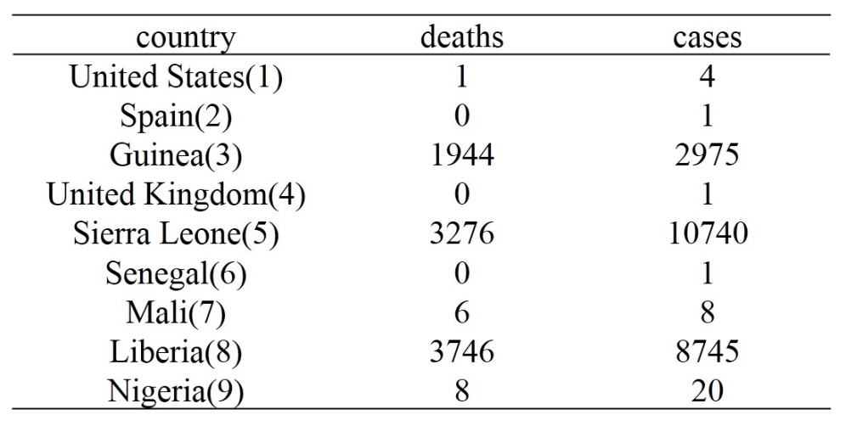

### 3.2.4 Minimum Spanning Tree Method (MST)

Firstly, given that *G* = (*V*,*E*), where *vi* stands for the areas which are assigned numbers.*vi*∈*V*,1≤*i*≤9; *E* stands for the lines which are linked to the labeled areas, and each line has power value that can stand for the distance between two areas.

The point the labeled areas to Fig 11.

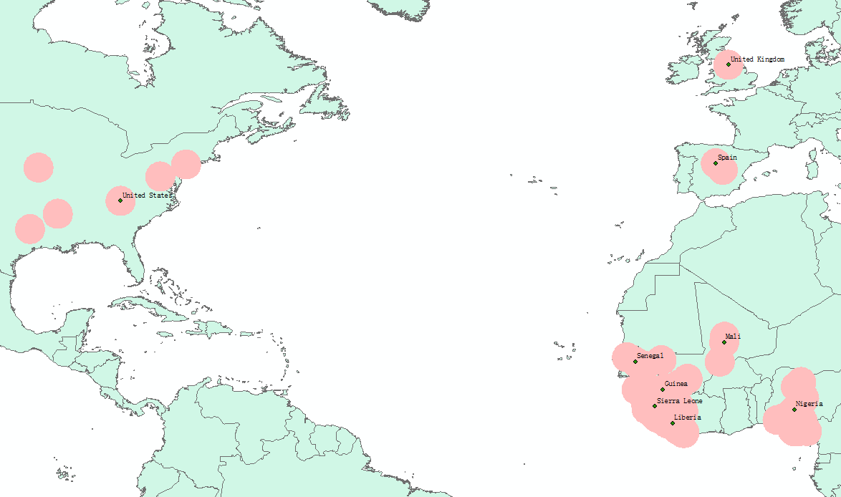

Fig 11. Ebola outbreaks location

And we measure the distances between each two points from Fig 5, and get adjacent the matrix:

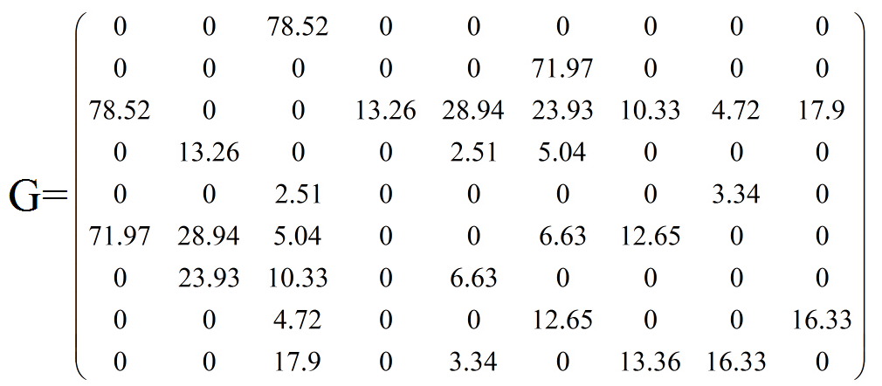

According to the MST model, we draft a cyclic graph and mark the weight of each edge on Fig 11. (To simplify the problem, we connect the cities with straight lines. However, the statistics of distances between areas are the shorteset transfer in which twist and turns inevitably appear.) So we get Fig 12.

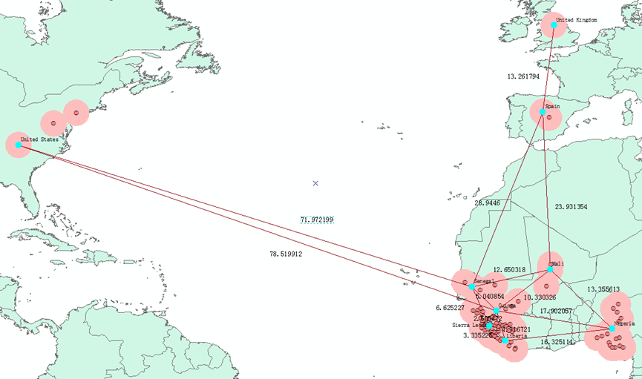

Fig 12. network spanning tree of 9 countries

We simplified the net spanning tree as Fig 13.

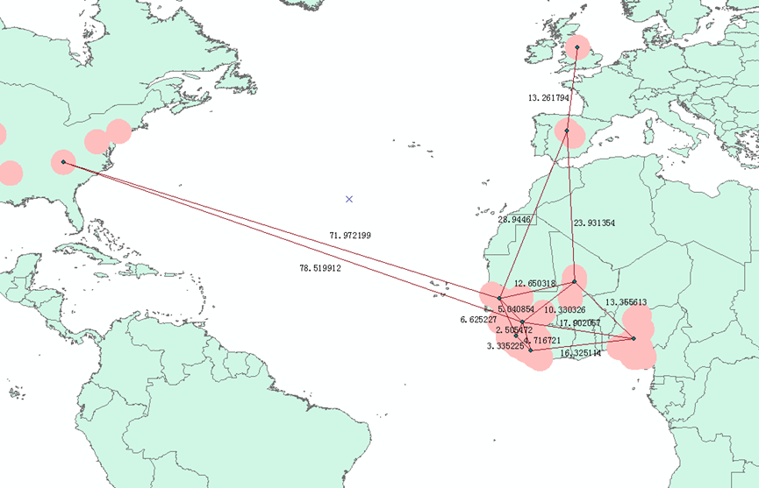

Fig 13. simplified network spanning tree

Kruskal’s algorithms above are realized by MATLAB, and we obtain the Minimum spanning tree-R:

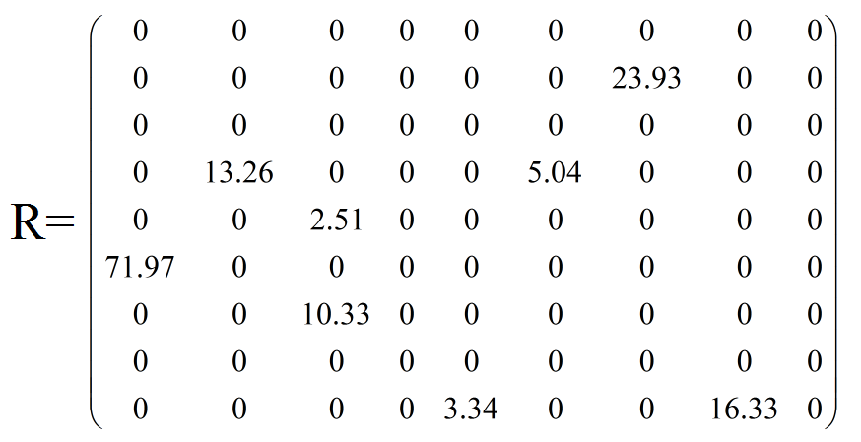

From the above calculation, we get the results on Fig 14.

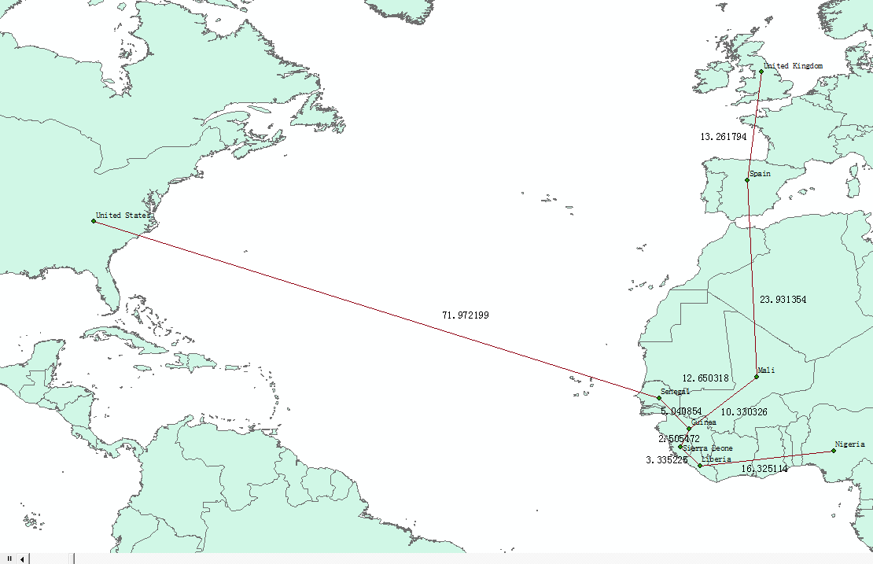

Fig 14. The minimum spanning tree of 9 countries

According to the minimum spanning tree, the number of the cases, the location of the pharmaceutical factory and the type of connection between different countries, the model determine that the following 3 countries should be the center location of delivery: United States, Spain and Sierra Leone. Take the Sierra Leone for example, this center location is most important due to that Sierra Leone has more than 10000 cases and that there are two more countries named Liberia and Guinea around Sierra Leone. Liberia and Guinea both have amount of cases more than 3000, these areas also need a large number of drugs to cure the infective individuals. So we use vehicle convey drugs from Sierra Leone Center delivery location to Liberia and Guinea on the land. Then with the same method, we delivery drugs to Senegal, Mali, Nigeria. And the sources of Sierra Leone Center delivery location are from the San Diego, California in the United States where has produced the new drugs treat to Ebola. Spain and United Kingdom are obtain the drugs through the aircraft from the San Diego. There is a delivery map describe the system in details as Fig 15.

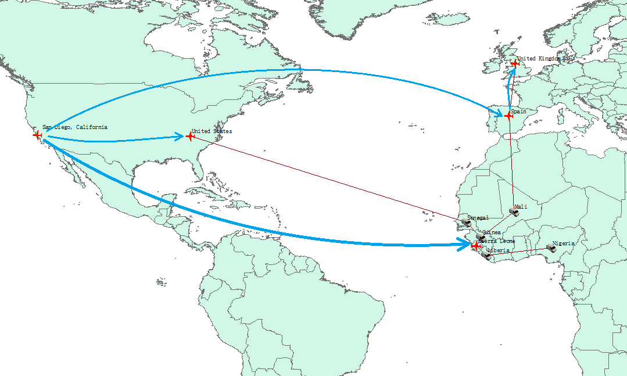

Fig 15. the delivery system and location

# 4 Drug and Vaccine Production

## 4.1 Background

ZMapp™ is an experimental new therapy that is being developed to treat patients with Ebola. It is comprised of a series of three different monoclonal antibodies that work to prevent the spread of the disease within the body. ZMapp™ has shown to be effective in a monkey model of Ebola in studies conducted by the Public Health Agency of Canada. The three different antibodies that comprise ZMapp™ are currently grown in tobacco plants. Antibody genes are infiltrated into tobacco plants to transiently manufacture the ZMapp™ antibodies. ZMapp™ antibodies are produced in tobacco plants for one week. Once the plants are harvested, the antibodies are purified, formulated for injection, and evaluated. A vaccine (active immunization) given prior to infectious exposure will prime a person's immune system to provide protection. Vaccines are excellent public health tools for protecting large numbers of people prior to exposure to a disease. However, once a person is infected, the passive immunity provided by specific antibodies like those used in ZMapp™ may enable a person to overcome the infection.

## 4.2 Assumptions and Justifications

* Assume that the facilities used for manufacturing medicines are sufficient.
* The drugs’ effect can reach 70%.
* Each infective individual needs n units of drugs each day.
* The demand for medicines and cases is linear dependence.
* Within predicted ranges, the outbreak of cases will not come to a full-blown but also will not disappear suddenly.

## 4.2 Variable declaration

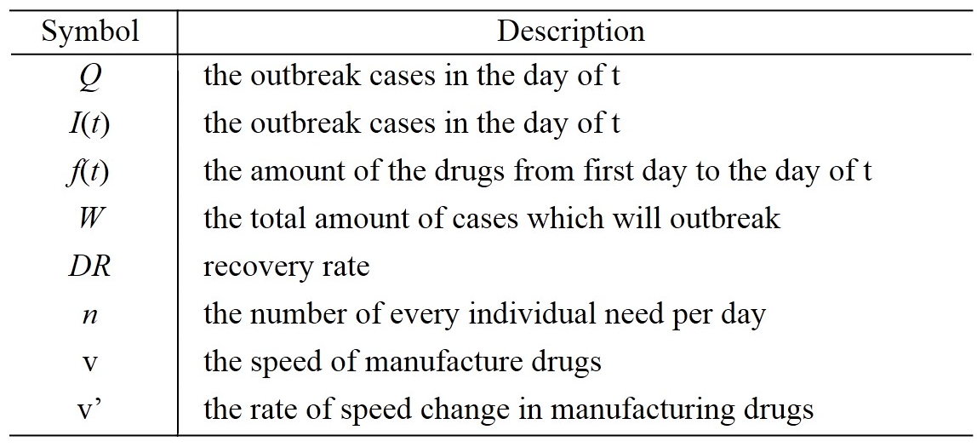

## 4.3 Modeling

### 4.3.1 Population Prediction Model

Before we calculate the drug demand, this model predict the cases in the future. According to the SEIRS Model in the chapter 2, we can predict the number of the outbreaks as Fig 16.

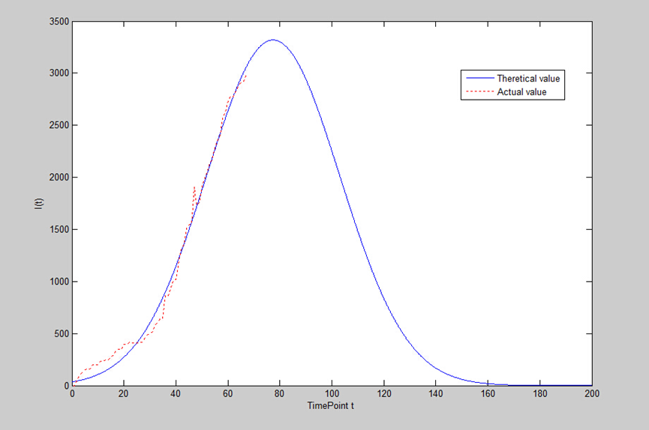

Fig 16. the number Ebola cases

This model can predict the accumulated cases.

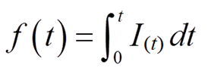

The change of the f(t) as Fig 17.

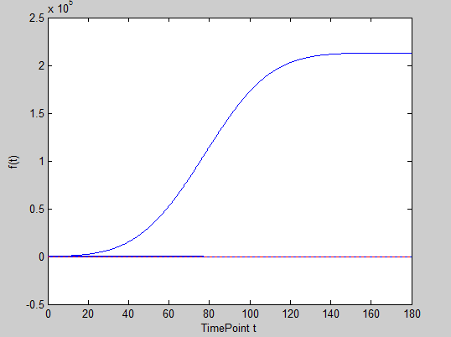

Fig 17. the transformation of the f(t) with t

The accumulated cases is increase slow at first, but with a few days later, the speed of accumulated cases increase up and down. Finally, the accumulated cases stabilize when the t=180.

Given that the need of drugs are related with the cases which will outbreak, we draw the

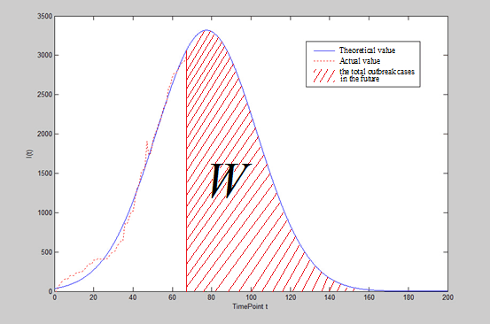

Fig 18. The total Outbreak Cases in the future (Red Shadow Area)

(From Feb 5th 2015 to the end day of the Ebola)

Form Fig 18, we conclude that the red shadow is the cases which will outbreak from Feb 5th 2015 to the end day of the Ebola.

So the W is

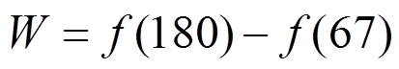

With the help MATLAB, we finally get the results:

C:\Users\pony\Documents\Tencent Files\364498319\FileRecv\无标题29.png C:\Users\pony\Documents\Tencent Files\364498319\FileRecv\无标题30.png

The total amount of accumulated cases:

C:\Users\pony\Documents\Tencent Files\364498319\FileRecv\无标题31(1).png

### 4.3.2 Drug demand Prediction

We have obtained the number of total cases which will outbreak, so we can get the total demand of the drugs (Q) according to the condition which are related with total cases (W) and recovery rate.

According to the assumptions before, every infective individual need n units of drugs, and this new drug can cure 70% (DR) infective individuals.

So, we can get the total demand of the drugs (Q)

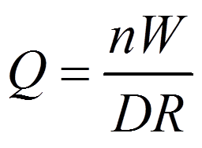

With the calculation, we get the result: *Q* = 200477*n* units

### 4.3.3 Drug Production Model

Currently, we have already predict the drug demand, and the new drugs require 7 days to manufacture completely. So the speed of production per day should be calculated.

The speed of manufacture drugs in each day

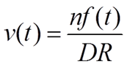

According to this model, we can get the amounts of drugs production in each as Fig 19

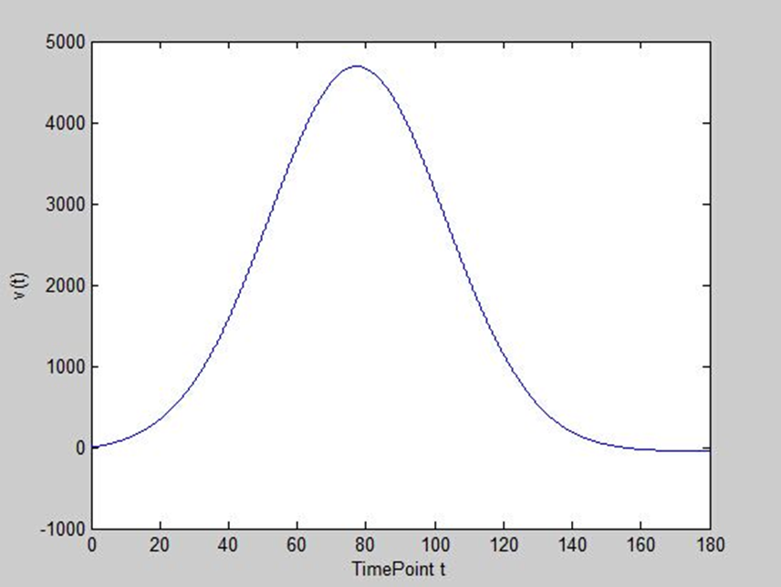

Fig 19. the amounts of drugs production per day

From this figure, the amounts of drugs production per day increase with the infective increase. When the quantity of the medicine needed is up to the maximum (about 4800 n units per day). After that, the amounts of drugs production per day is starting down with the t increase.

Besides, according to Fig 19, the rate of speed change in manufacturing drugs pre day can be obtained as Fig 20.

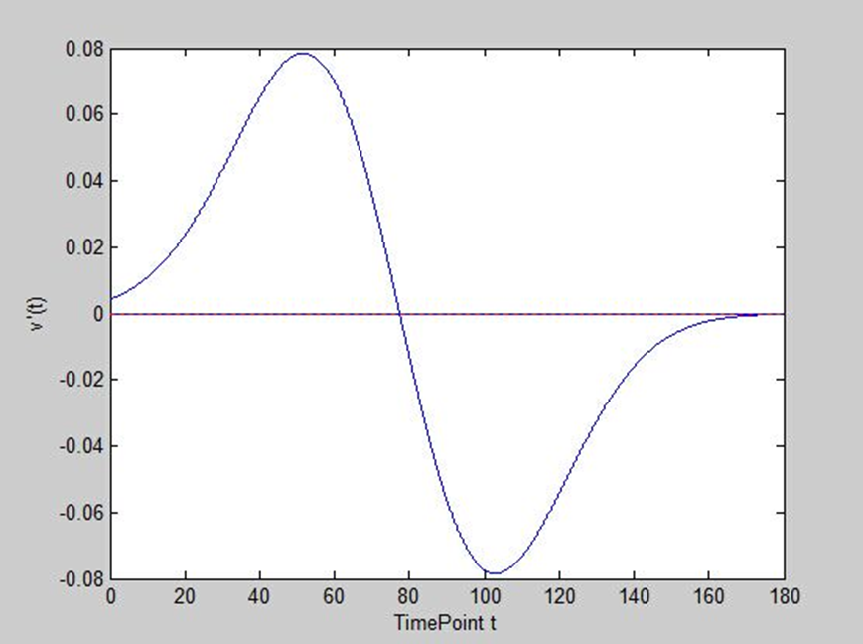

Fig 20. the rate of speed change in manufacturing drugs pre day

From this figure, it is read that the speed of manufacturing start to increase faster at first, when the t= 50, the rate of speed change is up to maximum (about 8%), then the speed of manufacturing is also increase, but the rate of speed change is down. When the t = 77, the amounts of drugs production per day is down, then the decrease rate is become higher, and the amounts of drugs production per day decrease faster. While, when t = 103, the rate of decrease is down, and the amounts of drugs production per day decrease slower. Finally, when t is near 180, the manufacturing of the drugs is stop. This date is about August 4th 2016.

# 5 The optimized isolation Area in SIRES Model

## 5.1 new Assumptions and Justifications

## 5.2 new Variable Declaration

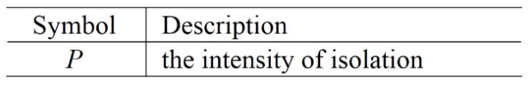

## 5.3 The Isolation Index Analysis

We changed the original SEIRS Model, taking isolation area into account. Before this, the latent individuals (E) are not isolated. Infective individuals (E) can infect susceptible individuals (S) without limitation. With this method, infective individuals infect others will be constrain by the isolation. The rate p represent the intensity of isolation. In other words, the p*100% of the latent individuals (E) are suspected to carry the Ebola, and they should be isolated.

According to the description, there is a map about the state of S, E, I and R as Fig 15.

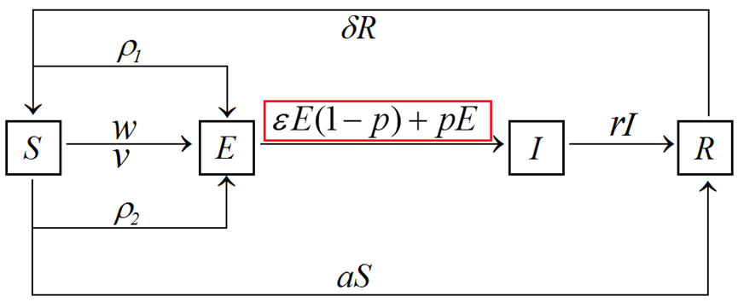

Fig 21. the relationship of different individuals

Let ρ=(ρ1E(t)+ρ2I(t)), and with the equation



We can get the following equation according the previous diagram of model.

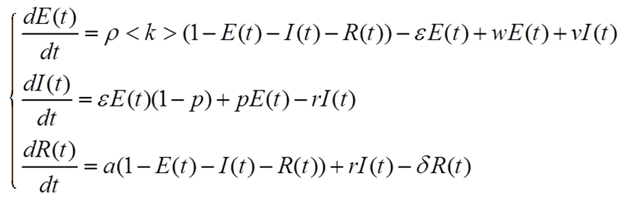

With the help of MATLAB, we get the map of different intensity of isolation as Fig 22.

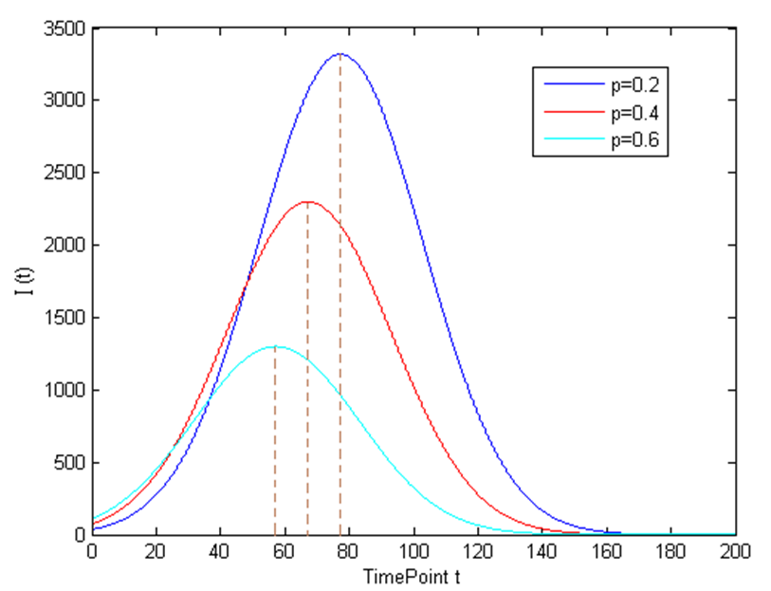

Fig 22. the cases number of different intensity of isolation

From Fig 16, with the p increasing, the number of Ebola reach the peak value earlier, and the peak value is lower. We may conclude that the isolation area can constrain the spread of Ebola effectively.

In a word, it is significant to build the isolation in the area where the Ebola outbreaks.

# 6 Paper for the world medical association

To Whom It May Concern:

It is high time to concern the disease of Ebola. The Eradication of Ebola mainly includes the following five aspects: the spread area and cases of Ebola, the quantity of the medicine needed, the delivery system and locations, the speed of manufacturing of the drug and the isolation area.

The spread area and cases of Ebola base on the current outbreaks Ebola in the world. We predict the cases of outbreak Ebola will reach the peak at April 4th 2015. The outbreak area is show as Fig 6 in the first model.

The delivery system of new medicine is designed at the most optimized network. The manufactory is located in the San Diego, California in the United States. The drugs is conveyed by the aircraft. And the destinations are arranged in the east of the United States, Sierra Leone and Spain. Then using the vehicle delivery the drugs to other countries, such as Liberia, Guinea, Mali and Nigeria.

The quantity of the medicine needed is related to the accumulated outbreak cases. The accumulated cases we predict will be 140334 from Feb 5th 2015 to the end day of the Ebola. It is necessary to prepare enough drugs, the exact quantity is 200477n units drugs and n units vaccines.

In addition, it is also vital to build the isolation in the outbreak areas. With an increasing rate of intensity of the isolation, the outbreaks of Ebola can be constrained.

And with the effort of the whole world, Ebola will be controlled at the date about August 4th 2016.

This paper takes the most technological and feasible methods. The model is realistic, sensible, and useful. Also, our mathematical model give the specific plan about the random in coming passenger and population density impacts.

Our lives are in your hands and there will be no regret.

Yours sincerely,

Team 37185

2015-2-9

# References

[1] http://baike.baidu.com/view/13076104.htm#2_1

[2] http://www.healthmap.org/ebola/#timeline

[3] www.vizinsight.com

[4] David M Pigott, Nick Golding, Adrian Mylne, et al. Mapping the zoonotic niche of Ebola virus disease in Africa[EB/OL]. http://dx.doi.org/10.7554/eLife.04395

[6] Geni Gupur, Existence and Uniqueness of Endemic States for the Age-structured MSEIR Epidemic Model [J]. Acta Mathematicae Applicatae Sinica (English Series), 2002(03).

[7] Xue-Zhi Li, Geni Gupur, Guang-Tian Zhu. Analysis of an Age Structured SEIRS Epidemic Model with Varying Total Population Size and Vaccination[J]. Acta Mathematicae Applicatae Sinica, English Series. 2004 (1).

[8] Newman MEJ, Watts D J. Renormalization group analysis of the small-world network model. Physics Letters. 1999.

[9] M. E. J. Newman. Spread of epidemic disease on networks [J]. Physical Review E, 2002, 66(1): 016128.

# Appendix

**Program 1**



% input of statistics data

t = [67 66 65 64 63 62 61 60 59 58 57 56 55 54 53 52 51 50 49 48 47 46 45 44 43 42 41 40 39 38 37 36 35 34 33 32 31 30 29 28 27 26 25 24 23 22 21 20 19 18 17 16 15 14 13 12 11 10 9 8 7 6 5 4 3 2 1 0

];

S = [2687025 2687080 2687091 2687129 2687175 2687225 2687231 2687270 2687370 2687429 2687584 2687646 2687717 2687836 2687866 2687953 2688029 2688081 2688240 2688269 2688094 2688447 2688460 2688481 2688650 2688702 2688801 2688978 2688992 2689058 2689138 2689138 2689352 2689352 2689393 2689421 2689481 2689505 2689515 2689540 2689585 2689590 2689591 2689591 2689588 2689587 2689610 2689602 2689649 2689649 2689666 2689709 2689719 2689752 2689752 2689764 2689769 2689803 2689803 2689803 2689842 2689842 2689849 2689873 2689897 2689951 2690000 2690000

];

R = [357.3 347.28 345.83 344.84 351.16 356.05 362.59 359.74 362.2 377.37 328.59 338.01 332.3 323.74 357.96 338.98 307.88 295.47 283.2 275.04 433.52 253.14 262.66 284.17 242.36 216.41 176.48 146.55 140.25 123.44 109.34 109.34 73.34 73.34 66.56 57.84 37.23 33.1 33.26 31.83 24.58 24.39 24.45 24.45 27.79 29.3 36.92 45.12 44.52 44.52 42.4 33 32.12 23.91 23.91 25.78 25 28.55 28.55 28.55 20.56 20.56 20.77 15.24 13.29 8.16 0 0

];

I = [2975 2920 2909 2871 2825 2775 2769 2730 2630 2571 2416 2354 2283 2164 2134 2047 1971 1919 1760 1731 1906 1553 1540 1519 1350 1298 1199 1022 1008 942 862 862 648 648 607 579 519 495 485 460 415 410 409 409 412 413 390 398 351 351 334 291 281 248 248 236 231 197 197 197 158 158 151 127 103 49 0 0

];



% ODE ( ordinary differential equation )

function dy = equation(t, y)

p1 = 0.2;

p2 = 0.4;

k = 5;

e = 0.6;

r = 1;

g = 0.4;

v = 0.05;

w = 0;

a = 0.1;

dy = zeros(3,1);

dy(1) = (p1*y(1)+p2*y(2))*k*(1 - y(1) - y(2) - y(3)) - e*y(1) + w*y(1) + v*y(2);

dy(2) = e*y(1) - r*y(2);

dy(3) = a*(1 - y(1) - y(2) - y(3))+r*y(2) - g*y(3);



% solve the ODE

t0 = 0;

tf = 67;

[t,y]=ode45('equation',[t0 tf],[0 0 0]);

plot(t,y(:,1),'b-')

hold on

plot(t,y(:,2),'g*')

hold on

plot(t,y(:,3),'r--');



% comparison of Infective individuals between Actual and Theoretical value

x = 0:0.1:200;%let x vary zero to two handred

a1 = 3319;

b1 = 77.41;

c1 = 36.28;

f = a1*exp(-((x-b1)/c1).^2);%The function of I(t)

plot(x,f)

hold on

plot(t,I,'r:');



% parameter fitting

m = 0:0.1:100;

f1 = 2814+(-2604)*cos(m*0.02907) + (-669.8)*sin(m*0.02907);

f2=46.83*m+(-459.7);

f3=1818*sin(0.02638*m-0.2324);

a1 = 3319;

b1 = 77.41;

c1 = 36.28;

f4 = a1*exp(-((m-b1)/c1).^2);%The function of I(t)

axis([0 100 0 3000]);

plot(m,f1,'c:')

hold on

plot(m,f2,'g:')

hold on

plot(m,f3,'k:')

hold on

plot(m,f4,'b:');

hold on

plot(t,I,'r-');

**Program 2**

The program file named ’mintrees’ is to get the Minimum spanning tree function.

function [b,u,w] = mintrees(a,k)

% the Minimum spanning tree, a: adjacent the matrix

if nargout==1

k=1;

end

[m,n]=size(a);

for i=1:m

for j=1:n

if a(i , j )==0

a(i , j )=inf;

end

end

end

b=zeros(n);

u(1)=k;

j=1;

v=zeros(1,n);

v(k)=1;

for o=1:n-1

sn=ones(3,n)*inf;

for xk=1:j

k=u(xk);

p=max(a(k,:));

for i=1:n

if v(i)<1&a(k,i)<p

p=a(k,i);

end

end

for i=1:n

if v(i)<1&a(k,i)==p

break;

end

end

sn([1 2 3],k)=[i,p,u(xk)];

end

[w(j),k]=min(sn(2,:));

j=j+1;

u(j)=sn(1,k);

b(sn(1,k),sn(3,k))=sn(2,k);

v(u(j))=1;

end

end

% Calculate the he Minimum spanning tree􀀀R by the Minimum spanning tree function.

% The following code is the network consisting of the water supply and demand areas.

G=0

R=0

G(1,[3,6])=[78.52,71.97];

G(2,[4,5,6]) = [13.26,28.94,23.93];

G(3,[1,5,6,7,8,9,]) = [78.52,2.51,5.04,10.33,4.72,17.9];

G(4,[2]) = [13.26];

G(5,[3,6,8]) = [2.51,6.63,3.34];

G(6,[1,2,3,5,7]) = [71.97,28.94,5.04,6.63,12.65];

G(7,[2,3,6]) = [23.93,10.33,12.65];

G(8,[3,5,9]) = [4.72,3.34,16.33];

G(9,[3,7,8]) = [17.90,13.36,16.33];

R = mintrees(G)

**Program 3**



% integral of I(t): f(t)

a1 = 3319;

b1 = 77.41;

c1 = 36.28;

syms x ;

f=int(a1*exp(-((x-b1)/c1).^2),x,0,x);

disp(f);



% derivative of v(t): v’(t)

clear;

x = 0:0.001:180;

a1 = 3319;

b1 = 77.41;

c1 = 36.28;

f=a1*exp(-((x-b1)/c1).^2);

F = diff(f);

F1 = 0*x;

plot(x,F,'b-')

hold on

plot(x,F1,'r:')

**Program 4**



% comparison of different intensity of isolation

clear

syms x;

f1 = 3319*exp(-((x- 77.41)/36.28).^2);

a2 = 2300;

b2 = 67.411;

c2=36.28;

a3=1300;

b3 = 57.41;

c3=36.28;

f2= a2*exp(-((x-b2)/c2).^2);

f3= a3*exp(-((x-b3)/c3).^2);

plot(x,f1,'b-',x,f2,'r-',x,f3,'c-');